Western Eagles

Editorial

Final Edition

2023

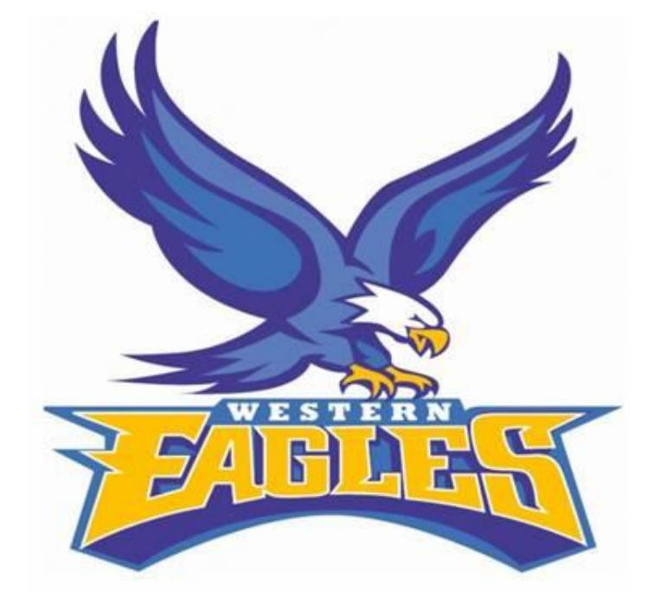

FROM THE PRESIDENT
Here we are again at the end of another season. It’s the time you look back and assess how the year has been…and what a year!
Each week we fielded 90 junior football and netball players, 100 plus senior football and netball players. We have over 450 club members and supporters with 65 plus sponsors. And let’s not forget our rising superstars our u12 footballers and our netball development
team. It’s pretty exciting seeing the future of the club wear the Eagles strip. Big thankyou to
Damien, Angus Fran & Leah for all the hard work they have put in.
We would like to thank our wonderful sponsors. Your support allows us to continue developing and growing our club. Our sponsorship base has again grown this year which is attributed to a dedicated sponsorship team. Well done!
The canteen & Thursday night coordinators Tanya & Emma and kitchen & bar staff Tracey,
Kate, Ali, Sally, Fran and all the mums, dads, husbands, wives, players, and kids that helped
out in our canteen, finals catering & social events… we thank you.
To Fran, Damien, & Dani and the fantastic volunteers that have helped get both football & netball teams on the field & court, from coaching, team managers, umpires, water boys, medical trainers, timekeepers, scorers, runners and the many more, we also thank you. The time you give our club cannot be underestimated and never goes unnoticed.

What a year!

All five junior football & netball teams playing finals with 3 junior netball sides playing in Grand Finals. B Grade just missing out by 1 goal, A Grade finding form in the last half of the season…if only there were a few more rounds. And what about our senior list that had 21 players under 23. Exciting times ahead!
Also Molly Fish, Georgia Oates, Remy Duynhoven, Angus Borgia & Jack Fish all winning Best
& Fairest awards for their grades. How good is that? Never has a CDFNL club managed to have all 5 juniors grades win a B&F in the same year.
And of course our u17 Netballers, Premiers & Champions! What an achievement.
We also had successful Hootnanny with 600 B&S ‘s this year. A complete sell-out 3 weeks prior to the event. This event is a huge contributor to the financial viability of our club and we would like to thank Kayelene for all the hard work and dedication she has put into this event.
Another milestone for our club is that we are currently in the process of designing our long awaited new club facilities. Still a lot of work to happen but how exciting!
What does this all mean? It means success, it means pride, it means that the Western Eagles isn’t going anywhere. Be loud, be proud and let’s continue to care about the great club we have.
Congratulations to all this year’s trophy winners.
We wish everyone a safe and enjoyable ‘off season’ and see you stronger than ever next
year.
Go Eagles!

A MESSAGE FROM FRAN

There are always a lot of people I feel need to be thanked at the end of every season. These people make my role easier & assist in the running of our club. A lot of people go into the running of a football club and for those who help out, your help does not go unnoticed.
A thankyou is extended to those who have taken on roles within the club, in
coaches, runners, umpires, trainers, match day helpers and to all who give freely of their time to give a hand at the club. Your help is invaluable & appreciated.
Double thanks to Damien Hickey who is the Team Manager for the U 14.5’s and got the U 12’s up & running for season 2023. He took on the coaching role of U12’s & did an amazing job with an assistant in Angus Reid. Damien is efficient and does a fantastic job for the U 14.5s and always volunteering to do more to lighten my load. I cannot thank him enough!
Thanks also to Milvo who took on the Team Manager job for the U 18s.
Special thanks to all the club helpers that help make game day. Goal umpires, timekeepers, water carriers and interchange stewards. Without them there would be no game.
To the canteen workers and the kitchen crew, who work tirelessly to keep us
happy & fed all year. Tanya has done an outstanding job in taking on this role. Special mention of thanks to the guys who put their hands up to be our club umpires. John Hickey umpired nearly very U 14.5 game, Greg Shalley the Reserves and various people in the U 18s with John Carbury doing a fair few of them. We could not play a game without you guys. This is a huge task that you commit to do for our club.
Huge thankyou to Andrew Mallon who I could not have done without this season. His help was invaluable to me again this season…thanks heaps Melso!!
The biggest thanks goes to Louis Hickey. Rain, hail or shine Louis fronted up to
run water for the seniors every single week, thanks mate!
You are all integral parts of our footy club and it’s a pleasure to be involved
with you all at the Western Eagles.

Fran

FROM THE NETBALL COORDINATOR

With another season coming to an end, we are left with so many positives to sit back and reflect on!
Our 3 junior teams made it all the way to the Grand Final again, with Under 17s coming over the line as premiers and champions! We were once again able to use juniors up in the senior teams, 8 of the Under 17s had regular spots in the higher ranks, and some of the Under 15s were given the opportunity to come up as well.
Across all teams we were able to show great numbers at most training sessions, as well as the club’s social functions. Our first
get together for the year was Ladies Night which we held round one. Being able to sit all together in the marquee and watch the footy was great! Thanks to everyone who helped make this night and every other social event for the year happen!
And how about our 5 Eagles winning league Best and Fairest across all grades? How amazing is that? Congratulations to Jack Fish and Angus Borgia, as well as Remy Duynhoven, Georgia Oates and Molly Fish. It’s so exciting to see what the club has coming along in years to come!
Leah Sherman, with help from Jancy and all of the supporters, ran another successful season of the Development team. We saw some new faces come into the side this year, some became regulars and others just popped by for a game or two. Either way it was great to see them giving it their all and having fun, well done team!
Under 13s finished second on the ladder at the end of the home and away season, and after fighting through each week they
faced an undefeated Bombers outfit in the big game. The girls played an amazing game, going goal for goal for a large portion of the match, before finishing down by a mere 3 goals, an amazing effort by all of the girls, well done!
Our Under 15s also had an awesome year, also finished second on the ladder and also played against Irrewarra-Beeac in the Grand Final, what are the odds! After showing really good abilities all throughout the court in the first couple of weeks of finals, Under 15s secured their spot in the decider. The girls fought hard for the whole match, unable to get it over the line. We should all be proud of their efforts not just in the finals, but throughout the whole season!
Under 17s, what a team! Fee and the girls have set the standard for all junior netball for the whole season. They started the year with 6 players, when Mia Compton, Rylee Reid and Camryn Smith made the decision to step up into the side. Being able to watch this team play was such an experience, all other clubs were in awe of their abilities and the amazing way they don’t even need to say a word to know where each other were. Congratulations girls on an awesome season! In the words of my mother, the illustrious Fran Bowen, “SCARY GOOD!”
C Grade had a great mix of youth and experience this year! Kess named Maddie McCrae and Charlotte Black from Under 17s in the side to play through the mid. They had some injuries and illnesses, and welcomed Sierra Ryan back into the side after she had her baby boy Huxley. Despite all of the ups and downs, C Grade managed to be competitive against even the strongest sides and finished in 6th place on the ladder, excellent effort ladies!
What a year we had in B Grade! The team suffered some injuries early in the season, which led to getting some C grade players to bench, before Mia Compton and Rylee Reid joined the team permanently. After taking it to most teams, only losing to South who held fourth place for most of the year by one goal, the team was looking pretty good! In the end B grade missed out on finals by 1 goal and 2 points.. Look out next year!
To see how far our A Grade side has come in just one season is so exciting! From the beginning of the season, 4 Under 17 players Remy Duynhoven, Tilly O’Brien, Briea McLachlan and Sienna Mallon, an awesome new player Charlotte Howell, and experienced players Ali Genua, Jancy Shields-Jackson, Leah Sherman and Keeley Hardingham working together to figure out what works, to the tail end of the season finishing with 4 wins in a row, including one against fourth place holders Otway Districts. Amazing effort, and I can’t wait to see how it plays out next season!
This year we started with an abundance of experienced umpires. We welcomed Grace Tevelein into the C Grade Badge club, congrats Grace! After a couple of injuries, some umpires stepped up to umpire 2 games a week when needed before they
played, thanks ladies! Thanks also to Barney, who did A and B Grade for us most weeks. With 3 of our badged umpires playing B,
I’m not sure what we would have done without you! Congratulations to Jenny Fish, Emily Montano and Barney Hay for being selected to umpire finals, and well done for Emily and Barney umpiring the D Grade Grand Final, amazing effort by everyone, you all make my job a lot easier!
A big shoutout to Grant Oates for brining in the new scoreboard, definitely an upgrade from the old one!
Thank you to Jen Fish, Fee Penny and Kess Duynhoven for all of your help throughout the year, as well as Fran for all of your advise with Play HQ and everything admin!
Thanks to the committee, trainers, timekeepers, scorers, umpires, runners, water boys, canteen people, bar people,
social committee, and every single other volunteer that put even the smallest of time back into the club for the year. A little goes a long way when a lot of people are giving it, and it’s all of that effort that allows us to thrive and enjoy the club that we love!
Congratulations to all of our trophy winners for the year.
Can’t wait to see you all for season 2024!
Cheers, Dani

CLUB MILESTONES

50 CLUB GAMES

Molly Fish
Georgia Oates Bronte Scott Georgia Egan
Jess Dellar
Libby Mott
Bella Lloyd Mia Compton Rylee Reid
Sierra Ryan

100 CLUB GAMES

Tyson Jones
Jonah Scott Kyle Egan Brad Morgan

Holly Unwin
Tilly O’Brien Briea McLachlan Sienna Mallon Charlotte Black

150 CLUB GAMES

Pat Hickey
Aidan Robertson
Jeremy Carbury
Elijah Reid
Remy Duynhoven
Mia Carson
Olivia Montano
Leah Sherman

300 CLUB GAMES
Danielle Bowen

350 CLUB GAMES
Jenny Fish

400 CLUB GAMES
Kess Duynhoven

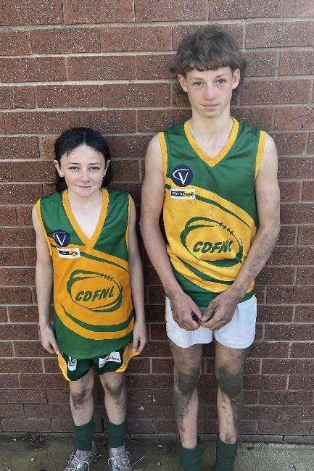
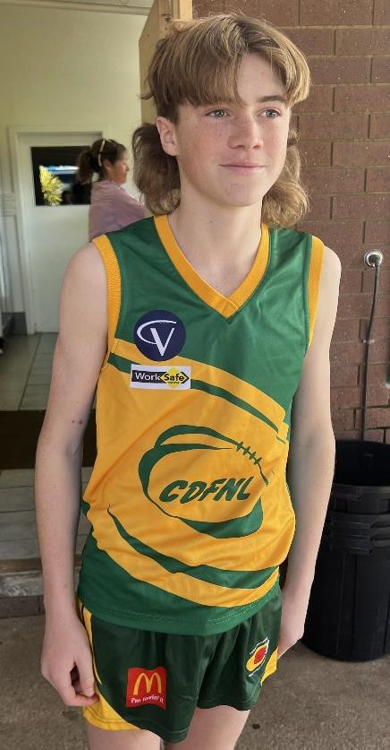
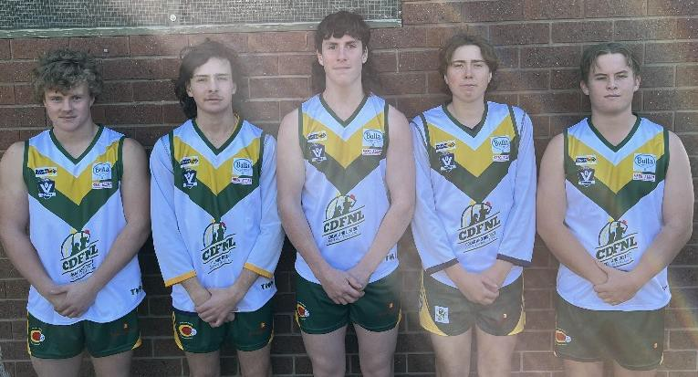
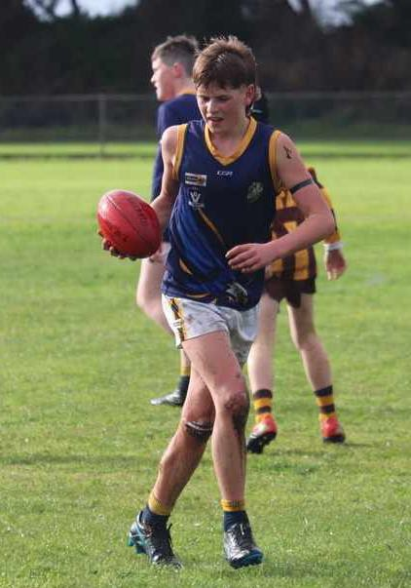
LEAGUE BEST & FAIREST
UNDER 13s – Molly Fish UNDER 14.5 – Angus Borgia UNDER 15 – Georgia Oates Under 17 – Remy Duynhoven Under 18 – Jack Fish

JUNIOR FOOTBALL

INTERLEAGUE
Under 13s | Ingemar Borrack
 | Harley Widdows
Under 15s | Levi Duynhoven
Under 18s | Nick Callahan
 | Jakeb Grant
 | Zavier Hunt
 | Baiden Luppino
 | Jordan Milverton

JUNIOR TALENT ACADEMY
Under 15s Angus Borgia

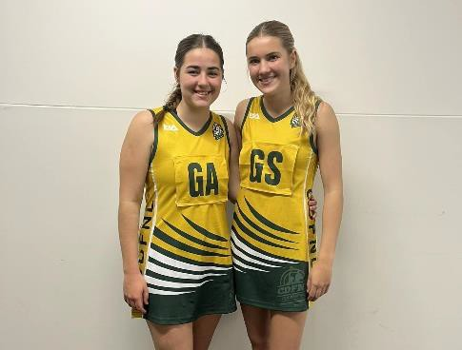
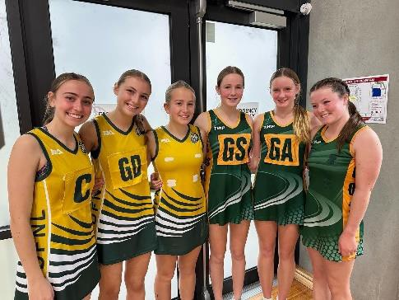
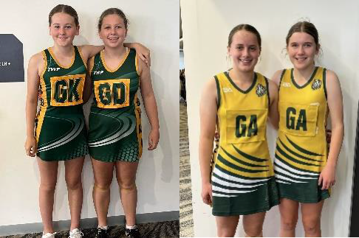
JUNIOR NETBALL
BARWON JUNIOR NETBALL
CHAMPIONSHIPS
Under 13s | Alexis Borch
 | Molly Fish
 | Ashlin Tate
Under 15s | Mia Compton
 | Georgia Oates
 | Rylee Reid
 | Camryn Smith
Under 17s | Remy Duynhoven
 | Tilly O’Brien
 | Briea McLachlan

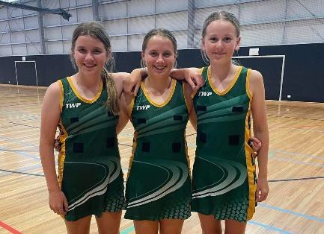
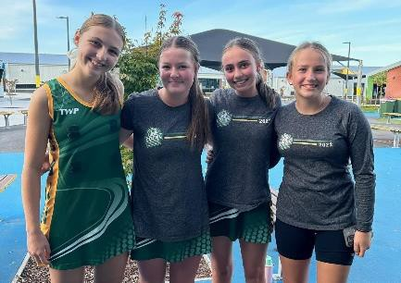
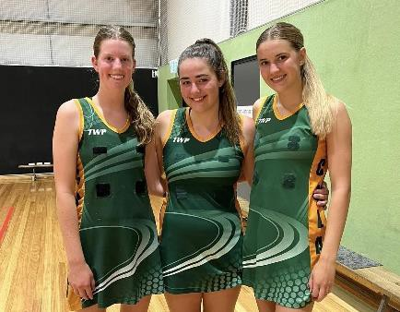

CENTRAL WEST ASSOCIATION
CHAMPIONSHIPS
13 & Under Div 2 | Alexis Borch
 | Chloe Hudson
13 & Under Div 1 | Molly Fish
 | Ashlin Tate
15 & Under Div 2 | Jessica Dellar
 | Georgia Egan
 | Camryn Smith
15 & Under Div 1 | Mia Compton
 | Georgia Oates
 | Rylee Reid
17 & Under Div 1 | Remy Duynhoven
 | Briea McLachlan




AGM

Tuesday 14th November
Irrewillipe Hall
7:30pm
All members are invited and encouraged to attend

WORKING BEE FRIDAY 29TH SEPTEMBER FROM 10AM MANY HANDS MAKE LIGHT WORK SO
COME OUT AND HELP IF YOU CAN!

FEBRUARY 10TH 2023
KEEP AN EYE OUT ON FACEBOOK FOR ANNOUNCEMENTS, WE WILL NEED YOUR HELP!

EAGLES REPRESENT!
SENIORS FOOTBALL TEAM OF THE YEAR Elijah Reid

NETBALL UMPIRING C GRADE BADGE Grace Tevelein

FINALS SELECTION Johnathan Hay Emily Montano Jenny Fish

D GRADE GRAND FINAL Johnathan Hay Emily Montano

FOOTBALL UMPIRING FINALS SELECTION Raymond Hay
Ben Tate Chris Egan Linda Knight Gary Bowen

UNDER 14 GRAND FINAL
Chris Egan

UNDER 18 GRAND FINAL
Linda Knight

RESERVES GRAND FINAL
Gary Bowen

SENIORS GARND FINAL
Ben Tate

UNDER 18 FOOTBALL

Best & Fairest – Jack Fish
Runner Up – Zavier Hunt Most Improved – Joel Beasley Coaches Award – Tom Fish
The 2023 season was another successful year for the Western Eagles under 18’s. We had fifteen players move on from last years’ side and welcomed eight players up from the u14.5 team. Patrick Cunnington, Rory Gaylard and Joel Beasley also joined the club
which was fantastic. In total we had ten bottom age players, six second year players and seven top age players. To finish the season playing such competitive football in two finals was a credit to the boys for all the hard work they put in throughout the year.
The standards were set by the leaders of our side, Jordan Milverton, Nick Callahan and
Jakeb Grant, who got all players committed to training Tuesday and Thursday nights from February onwards. I’m sure no other U’18 side would have had as many players training on a Tuesday as the Eagles. This really helped our performance in the second half of the season.
After round nine we were two wins and seven losses, at this stage it would have been
easy for the boys to drop off training and throw in the towel. To their credit they kept at it and a 30 point comeback victory against Imperials led to a winning streak of nine of the last ten games. Defeating every side in the competition apart from Irrewarra-Beeac. Congratulations to all our trophy winners, no one worked harder at training than Jack Fish and Zavier Hunt, so their achievements are very well deserved. I thank each and every player, not just in regards to football but also for what each of you contribute to our club as young positive members of the community. I really enjoyed our time together this year.
Many thanks to Riley Lawler for all the time and effort he put into the co coaching role
this season. Your work is greatly appreciated. Darren Milverton did an outstanding job as team manager, many thanks Milvo! It was great to have Angus Reid as our team runner this season. It is a big commitment for a young senior player to take on this role, thanks very much Angus. As always, thanks to Fran for all her work and for capturing many great shots through the lens. Thanks also to the u14.5 boys who played with us when we were struggling for numbers throughout the season, Angus, Reece and Ingemar. Definitely stars of the future!

Finally, thanks to all the parents for your support and for helping out with whatever roles were required throughout the year. It was an absolute pleasure to coach your children.
Cheers, Phil

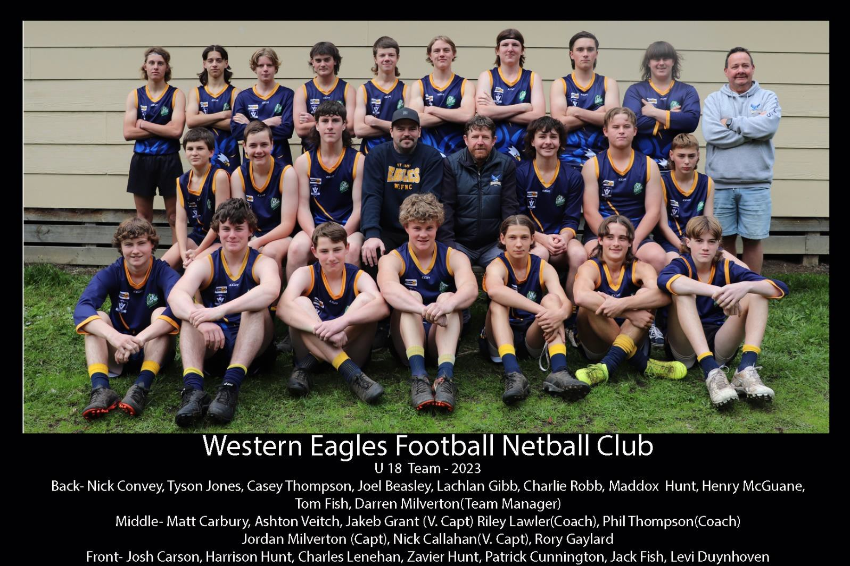
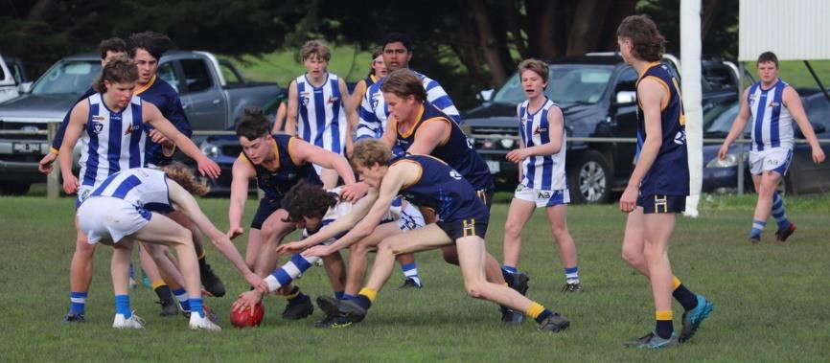
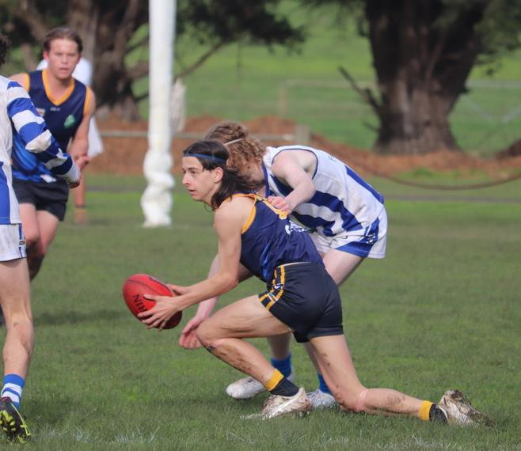
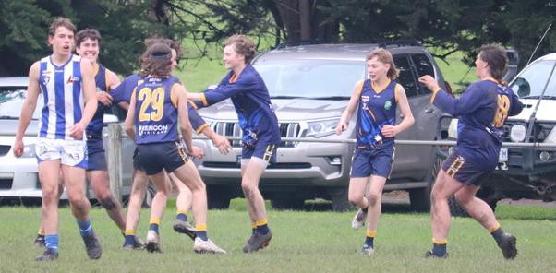
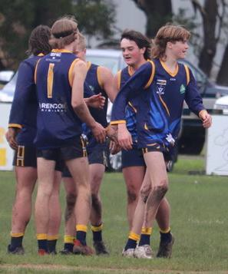
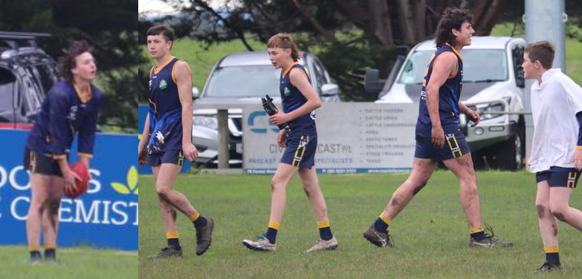

UNDER 14.5 FOOTBALL

Best & Fairest – Angus Borgia
Runner Up – Reece Hunt
Most Consistent – Blake Wales
Most Determined – Ingemar Borrack

Firstly, we’d like to thank everyone who has helped out this season including John Hickey who did the umpiring this year for us, Damien Hickey who was our team manager and made our job so much easier by having everything organised and Brad Kent who was the runner for the year.

We’d also like to thank the players and their parents from this season for your commitment and helping by being involved in a fantastic season. A much-improved season from last year, with a very young list the under 14.5s made the finals and ended up finishing 5th for the year.

To the players we would like to thank you for your continual growth and willingness to learn throughout the entire season, it was really good to see the individual improvement in each player from start to finish especially having such a young side.

Thanks to all the parents and volunteers that helped with goal umpiring, scoring and in the canteen through the course of the year. You have all made this season run very smoothly for us and this has been very much appreciated.

To the committee for allowing us to undertake this opportunity for the second year, we thank you very much and have learnt a lot in the process.

Thank you to everyone for making 2023 a very successful year. We look forward to seeing you all again next season in 2024.

Thanks Elijah and Luke

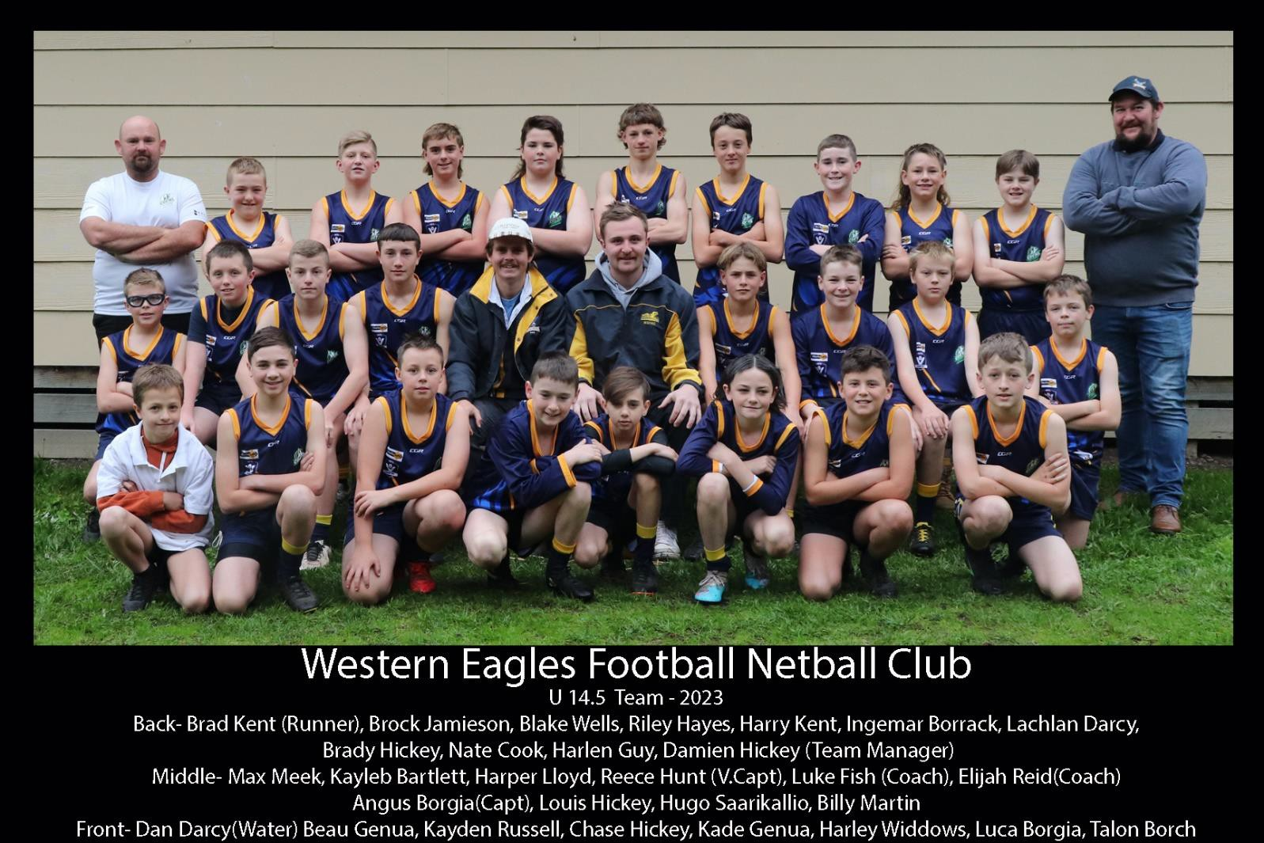
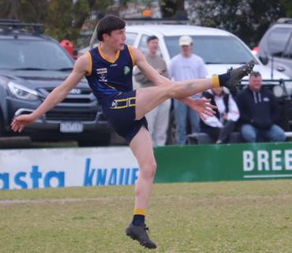
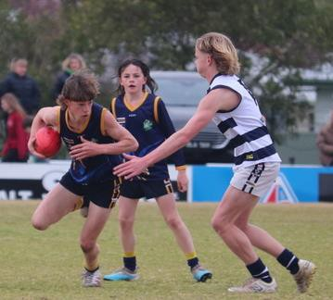
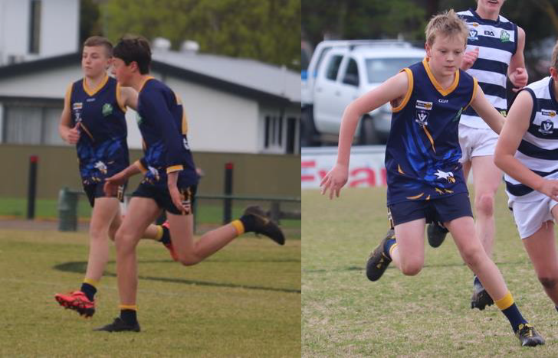
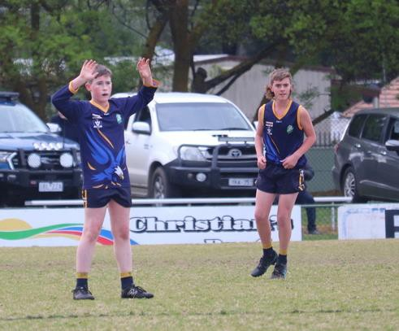

UNDER 12 FOOTBALL

Ray Hay Award – Luca Borgia Most Consistent – Harley Widdows Most Consistent – Louis Hickey
It’s been years in the making and it finally happened. The Eagles have finally unleashed an unruly bunch of
rough headed eaglets (which is bulldog crossed with a rabid tiger). Unsure on how this would turn out we appointed Angus Reid and Damien Hickey as the eaglet tamers/coaches. Under the watchful eye of the godmother of the club Lady Fran. After a great deal of swearing and numerous counselling sessions with the coaches and the godmother we were ready to start. On a strict diet of raw meat and gravel the boys hit the ground like satan’s soldiers. With no real expectations and a fingers crossed approach we went into the first game hoping no opposition players or spectators would get seriously hurt.

However, we soon realised that this unruly bunch of misfits could play football and play football they did beating Apollo Bay with ease. With the first win under their belts the boys got hungry disposing of everything they come in contact with only one side narrowly beating them in a fair fight. Not only did these boys do themselves proud but they did their club proud with every one of them contributing with best on ground performances, goals and big jobs brutally shutting down opposition forward lines. The skills, dedication and never quit attitude the boys displayed all year was an absolute credit to the young men they are and will be a force to be reckon with for years to come.

The boys found themselves thrown into the limelight every week with their heroes from the senior ranks proudly turning up to support and secretly learn from the eaglets that know no quitting. Overall, it was a very successful year with great support from parents, the senior football team and the committee.

Well done boys! We look forward to bigger and better things which will definitely come as the years go on.

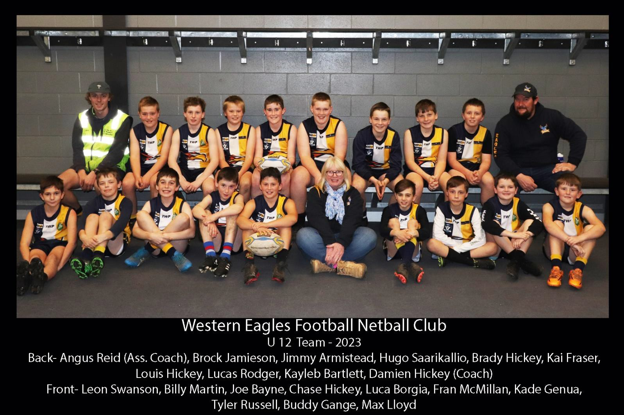

JAKE INGLIS MEMORIAL
AWARD

The Jake Inglis Memorial Trophy is awarded for the Best Team player in the under 18s. It is decided by the coaches, for someone thinking of the team, someone unselfish and always willing to help.
Just a bit of history about the award…..
It was instigated by Brian & Trish Inglis in memory of their son Jake in 2003.
Jake was taken from his family at a young age. He was only 8 when he passed away from illness.
Jake was a very popular, friendly, outgoing, full of life kind of guy. Never a day went by that he didn’t bring a smile to your face through his cheekiness & great sense of
humour, and he was old beyond his years.
He was seldom seen without a footy tucked under his arm
& was always wanting to have a kick with anyone around. He loved life and he loved football not to mention he was a huge Hawks fan.
This award to honour Jake’s memory goes to someone who exhibits the special qualities that Jake had & qualities we would all admire in a person.

This year the Jake Inglis Memorial trophy goes to ….
JORDAN MILVERTON

UNDER 17 NETBALL

Best & Fairest – Remy Duynhoven Runner Up – Briea McLachlan Coaches Award – Rylee Reid
Best in Finals – Remy Duynhoven

Premiers, Champions and a League B&F winner - doesn't get much better than that, considering at pre season we only had 6 players. So Mia, Camryn and Rylee put their names forward to come up from U15s. There was never any doubt that these girls would be more than capable and they've definitely proven that. It's hard to believe they still have 2 years in u17s. Rylee and Mia also had a regular place with B grade. This team had the perfect balance of strength, passion, determination, pride, willingness, skill and versatility. We could also adapt when we were short of players, which allowed us to try some different positions and involve 3 more u 15s to help us out. Big thank you to Jess Dellar, Georgia Oates and Libby Mott for qualifying and supporting us in the finals.
For anyone who watched throughout the year, whether it was U17s or A grade, there was no ignoring the incredible partnership of our goalers Remy and Briea. What they share isn't anything you can teach - its an incredible bond that amazes and leaves people in awe, assisted by the delivery into the ring by our midcourt - led by Sienna assisted by Mia and Maddie.
Our defending combination of Tilly, Riley, Charlotte and Camryn worked hard across
the season which became so evident in the finals when South and Irrewarra struggled to get past them and into their goalers. It was great to hear how proud Rylee and Tilly were with themselves after the Grand Final with the way they worked together - hard work does pay off.
There were definitely games that were one sided - highest winning margin of 79. But we also had slow starts and challenges, but not once did the girls stop playing as a team. They picked each other up and they supported and encouraged each other. When an opposition umpire approached me after a game and commended us on having such a positive bench - I was so proud. There can be a lot of negativity in sport and those things can have more impact than people realise. We need to continue to enjoy the friendships we have and love the challenges that come with the game.
I've been very lucky to have Keeley and Ali to help me out courtside, along with Kess,
Jenny, Tanya and Dani's support along the way. A huge thanks to all our umpires, helpers, committee and supporters for everything they have done to make this season a huge success.

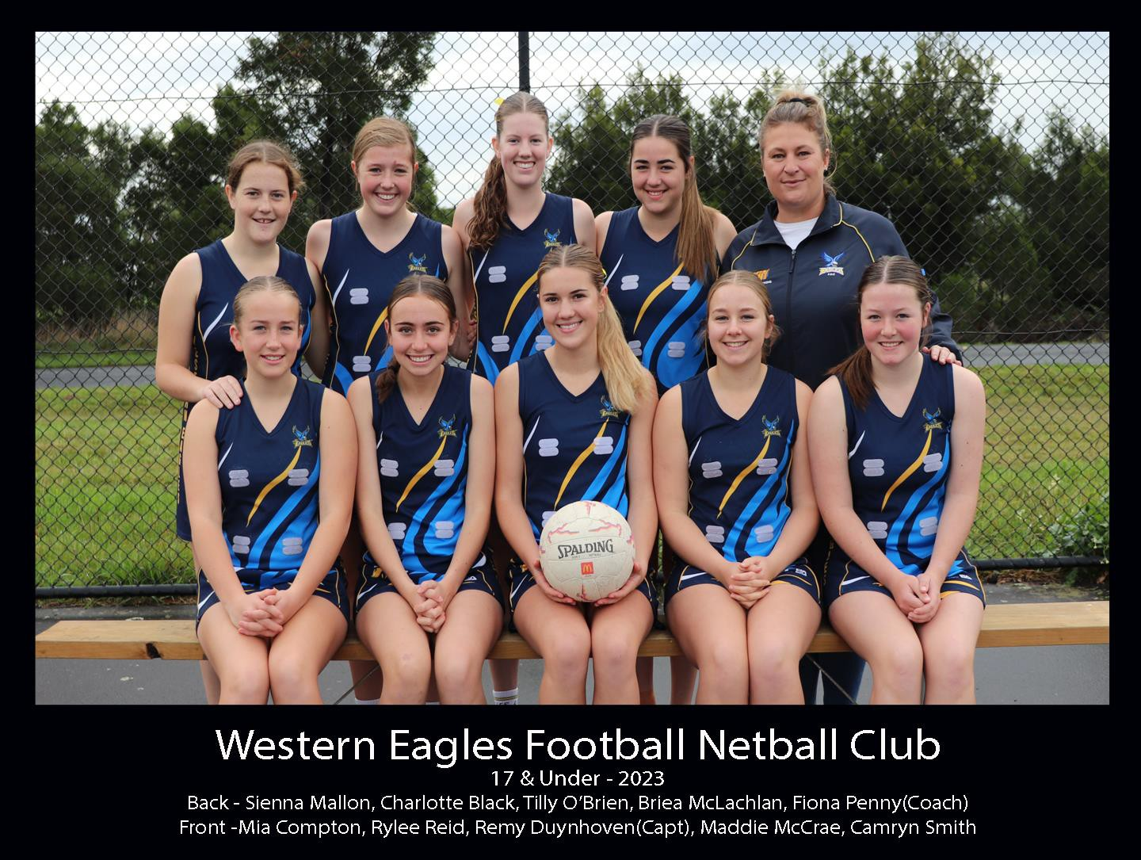
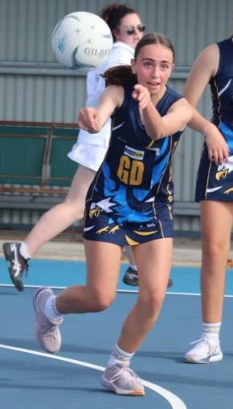
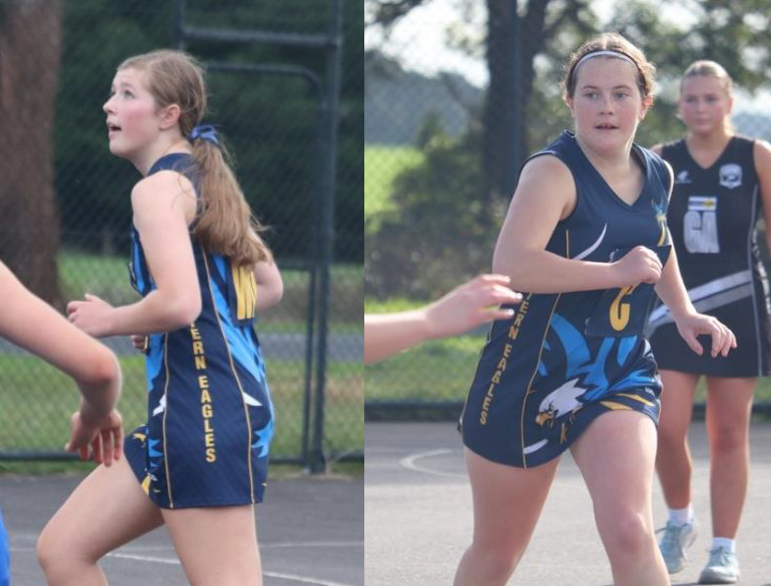
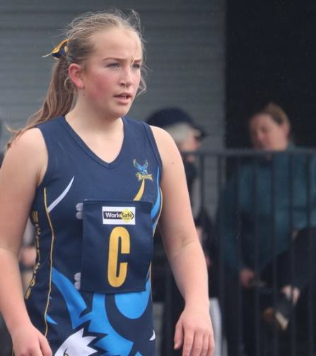
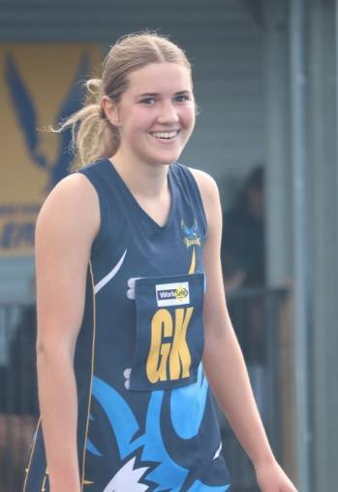
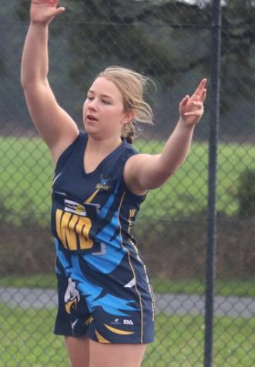
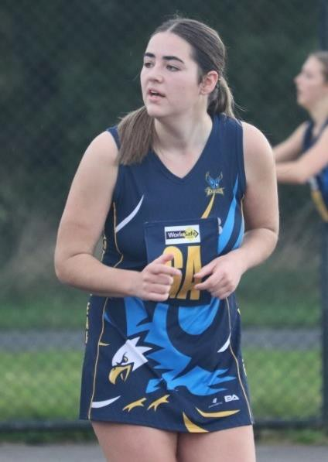
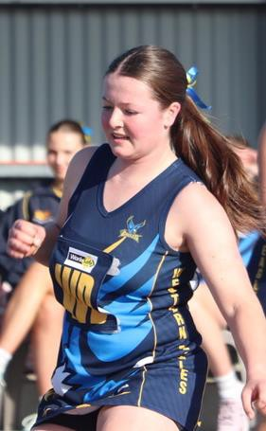
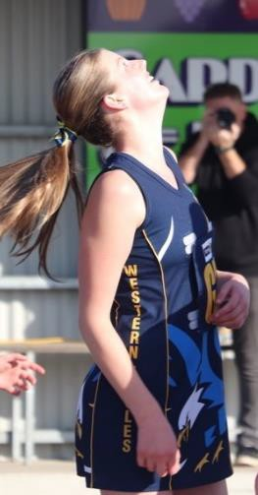

UNDER 15 NETBALL

Best & Fairest – Georgia Oates Runner Up – Jess Dellar Coaches Award – Libby Mott Best in Finals – Jess Dellar
Another great year from the U15 girls after a premiership winning season last year. We went through the home and away year with only 1 loss and finished second on the ladder behind Irrewarra Beeac. Our first 2 finals were hard fought wins to go straight through to the GF to again play IB. In warmer conditions than we were used to, we stuck with them till half time. Things didn't quiet go as planned after that, and we ended up losing by 12.
Nothing to be ashamed of, we fought till the end, we were gracious in defeat and the club is super proud of you all. Thank you to our captain Georgia Oates who warmed the girls up every week, is our club B & F Winner and as well as League B & F for the second year running.
Thanks also to our manager Susan Egan and primary carer
Sharon McCrae.
To Dani and her committee and umpires, thanks for the time you put in to get us all on the court.
Thanks to John and his committee and everyone else that makes this club run.
It's such a wonderful club to be a part of.
See you all for tryouts soon and look forward to the 2024 season.
Cheers Jenny

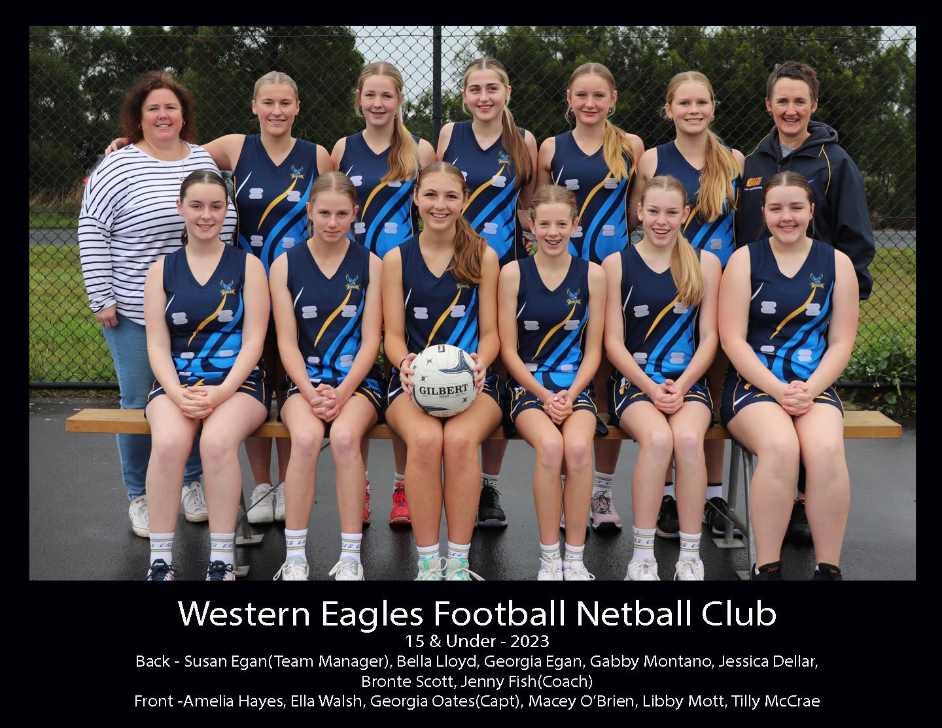
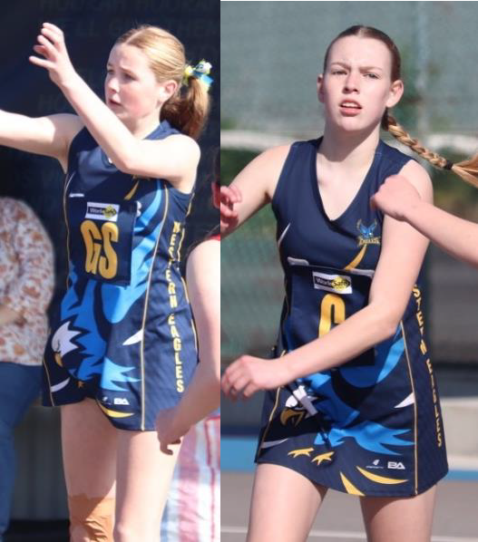
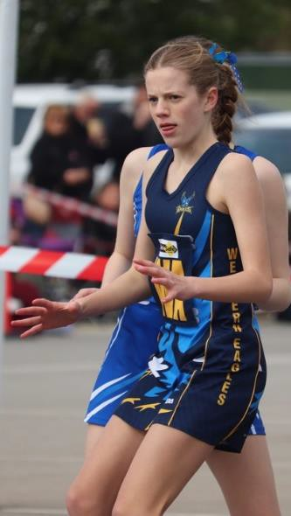
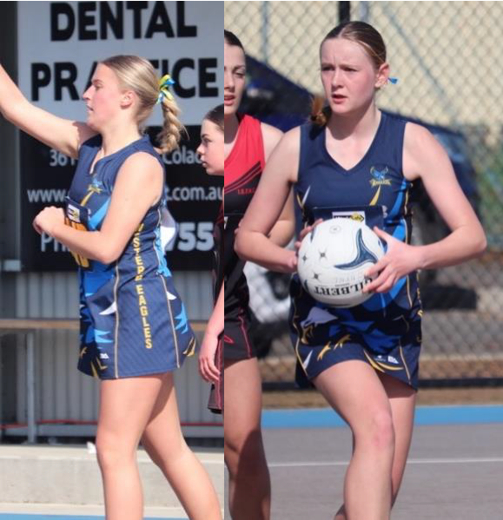
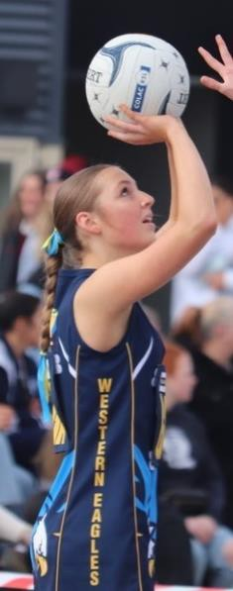
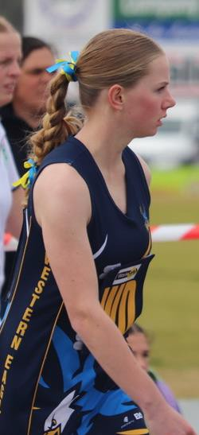
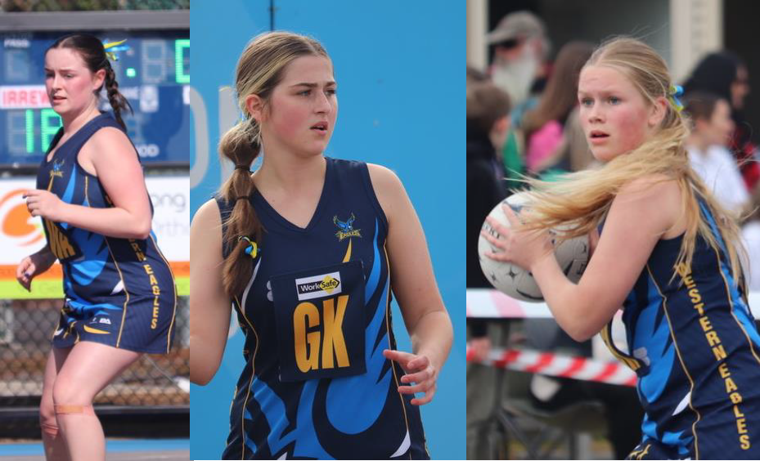
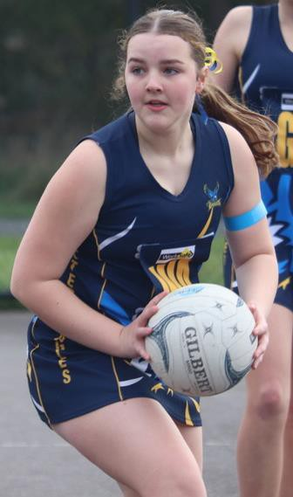

UNDER 13 NETBALL Best & Fairest – Molly Fish Runner Up – Ashlin Tate Coaches Award – Chloe Hudson Best in Finals – Ashlin Tate
What an amazing season it has been. To have all our junior netball teams in the Grand Final 2 years
in a row says a lot about not only the talent of players we have but also the environment we all, the Eagles Community, create for our players to flourish.
Our 13& Under group has had a fantastic year on the court, winning lots of games to end the
season 2nd on the ladder. Off the court these players have continued to grow and develop their netball skills and knowledge, going from strength to strength in terms of leadership and teamwork. League vote count was very exciting night winning all age groups, I believe this is the first time in history that one club has done this. Molly took out the 13 & Under division on a massive 47 votes out of a possible 54, very consistent and impressive season by Molly, and totally deserving of this award.
We had 4 girls represent the CDFNL in the 13 & Under Interleague Teams. Molly and Ashlin in the
Division 1 team and our defensive duo Chloe and Alexis in the Division 2 team. They represented the CDFNL in Altona at the Association Championships, Barwon Junior Championships in Geelong and Interleague game the league hosted in Colac.
Grand Final day was so exciting, even though we didn’t get the win, I felt like we had. The standard of netball from these young ladies was ridiculous and every single one of them played their hearts out. I couldn’t have of asked for more. We nearly pulled off the upset of the season. I was so proud. Well done girls.
I would like to thank all the parents for their support, helping out with oranges, lollies, setting up early on Saturday mornings, scoring, timekeeping and all the little jobs in between.
Thanks to Dani, Jenny and Fiona for their help and support with all things netball.
Thank you to Bec Tate for being our awesome primary carer throughout the last 2 years, we know we are in safe hands with you.
Thanks to Fran and Boydie for being our trainers during finals. Thanks to all our supporters during
the year and especially cheering us on in the finals.
I would like to congratulate Fiona and the 17’s girls on a well deserved win. It’s been an absolute delight to watch these girls grow and develop into some of the best players in our league. Congrats to Jenny, Luke, Elijah, Phil, Riley and teams on all making finals, it’s a fantastic testament to our club, although disappointing I’m sure you will all come back more determined next year.
A massive thank you to my team manager extraordinaire Kathryn. We’ve been a team for 4 years now and I cannot express how grateful I am for all you support, organisation and friendship during this time.
Thanks to John and the committee for doing an awesome job of running our great club. There’s such a fantastic feel around the club and I can’t wait to see where we can go next year.
Finally to all the girls, I’m so proud of you all, for your willingness to learn, your sportsmanship and
your determination to always give your best. You’re all amazing.
Cheers Kess

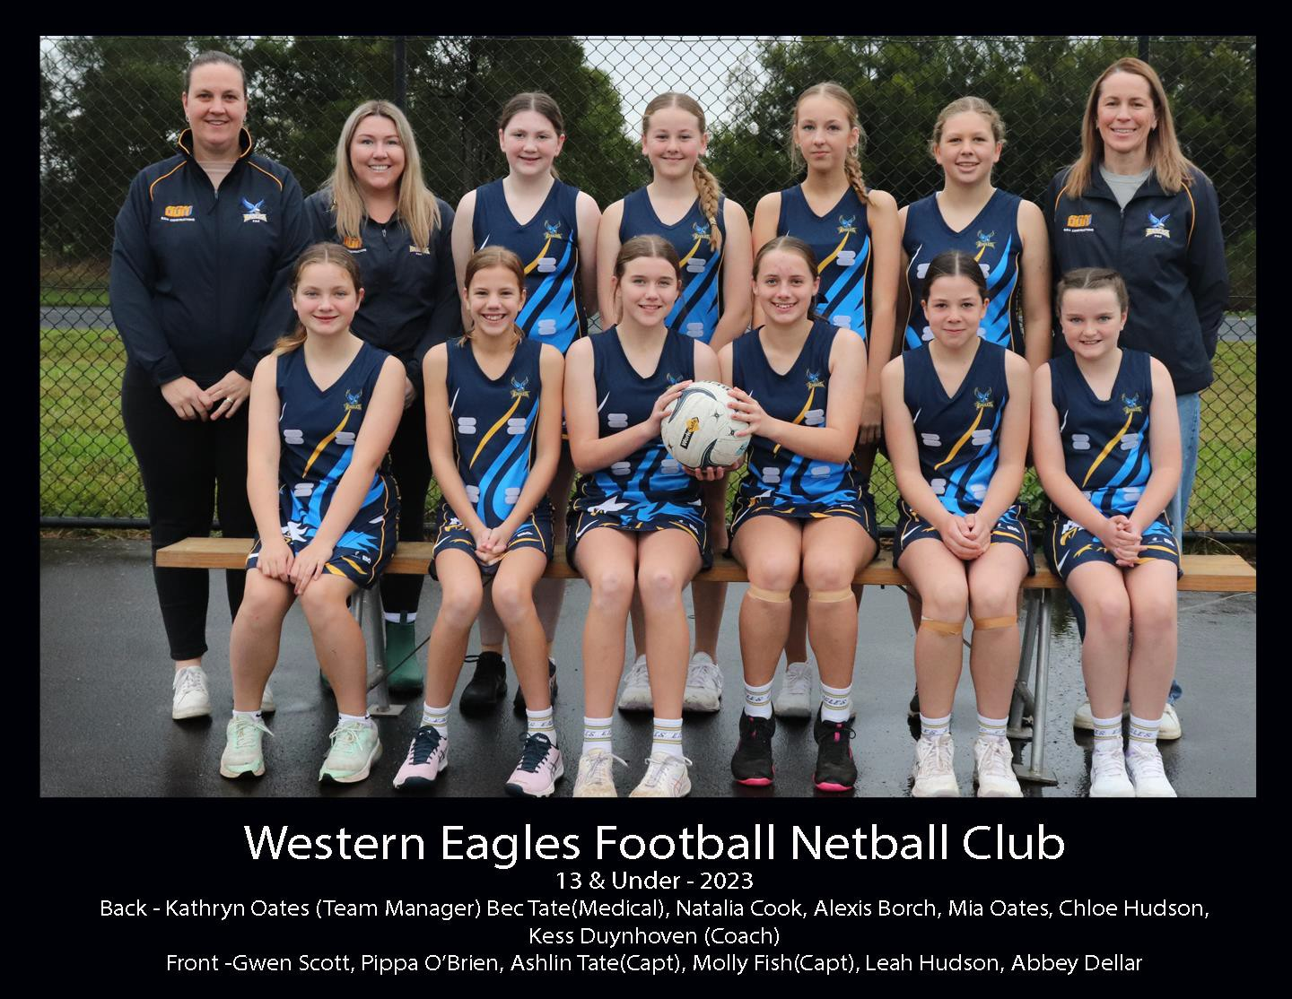
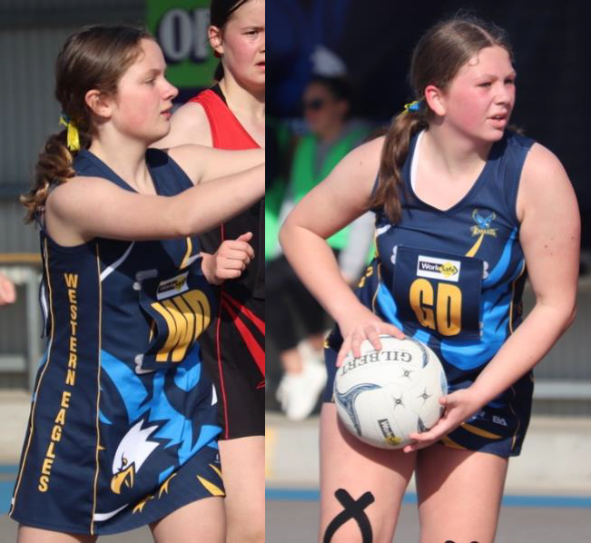
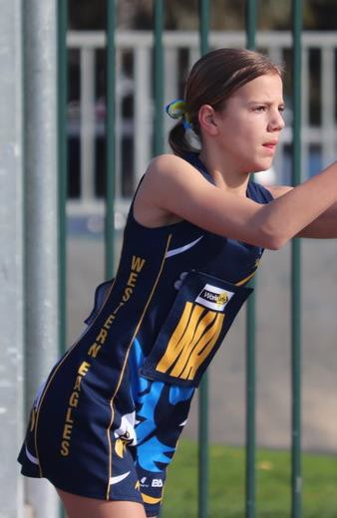
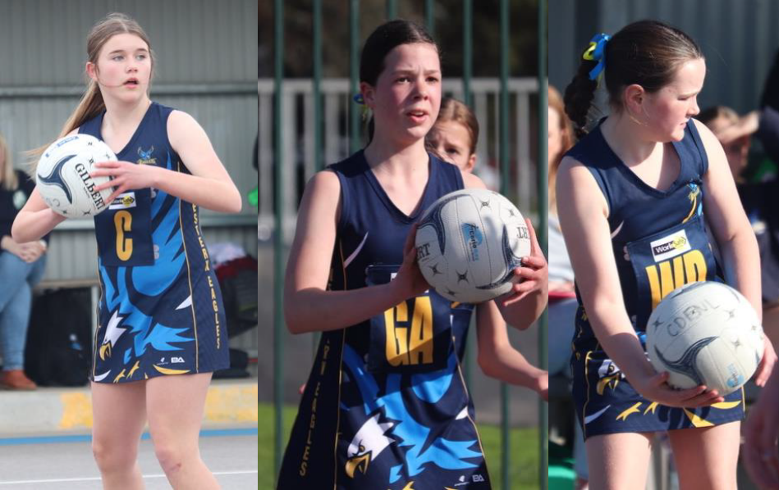
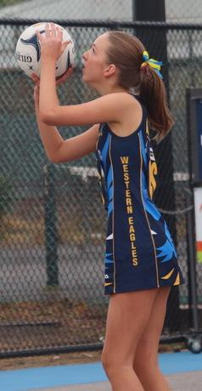
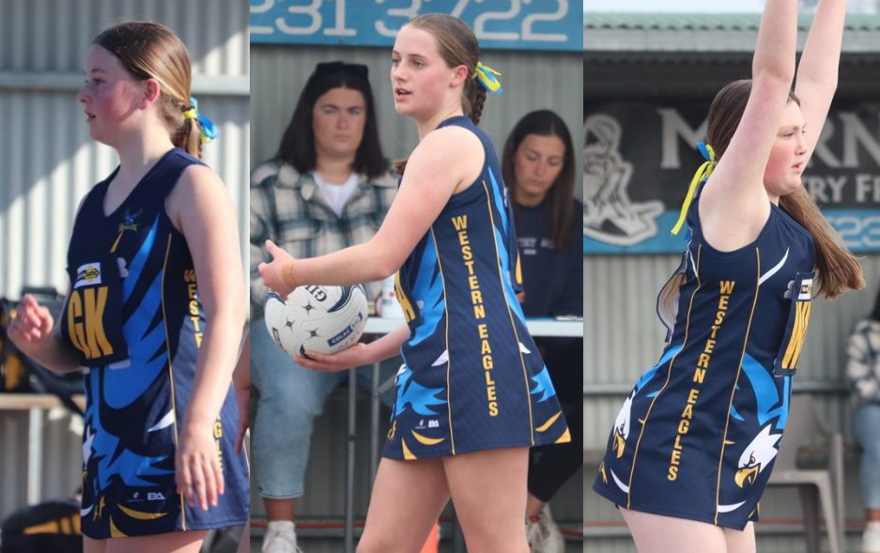

NETBALL DEVELOPMENT TEAM

What a season for the development group, this is my 2nd season mentoring this group and it has been a wonderful experience. We had a couple of players move up to U/13 this season which have
been exciting to watch. Our numbers continue to grow for dev group
and it’s great to see both the boys and girls giving netball a go. We increased our development group sessions to every home game this season as the little Eagles were extremely keen & played games against Birregurra, Apollo Bay, Otway, Imperials & South Colac. It’s great to see the numbers are strong with other CDFNL teams also. The skills, development, team work and friendships these kids have built have been great to watch.
Thank you to the parents, our sidelines supporters and Jancy and
Dani who have helped during the year, looking forward to season
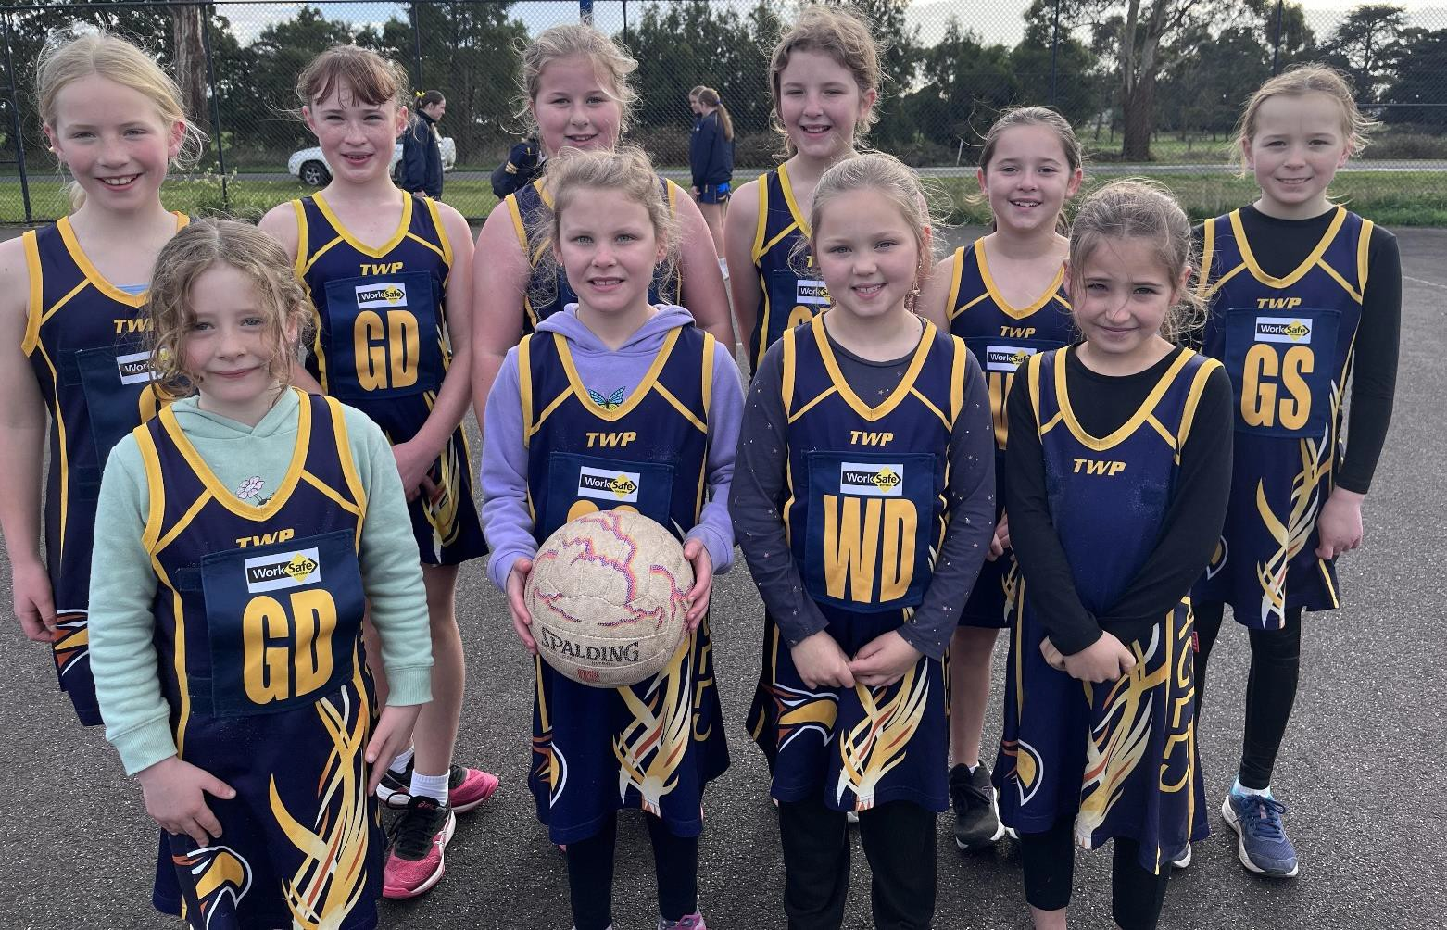
2024. Thanks, Leah

BAKERS DELIGHT
HIGH ACHIEVERS AWARD

Since being instigated in 2004 the Bakers Delight High Achievers Award has been bestowed upon many very worthy recipients and this year is no exception. The award was initiated by Mick Menzies proprietor of our local store and is to be presented to a young member within our club who demonstrates not only sporting excellence, but good character, work ethic, club loyalty, academic achievement and leadership qualities. After considering all the award guidelines it is with great pleasure that we announce the 2023 Bakers Delight High Achiever Award winner is…

JONAH SCOTT

Jonah started playing football for the Western Eagles Football Netball Club in 2018 in the Under 14.5 side. He has played 104 junior games for the club.
Whilst Jonah is representing the Eagles in footy, he displays good sportsmanship and is a true team player on & off the field. Last year he even stepped up to run the boundary in a Senior game when no-one else was prepared to do so. Jonah’s family also has had a long association with our club, firstly with Pirron Yallock & then the Eagles.
Jonah is currently a Year 12 boarding student at Ballarat Grammer where he takes on housing responsibilities and is held in great esteem particularly around public speaking.
Jonah is hoping to move to university in Melbourne next year to perhaps follow an engineering career path. At the moment he divides his time between his commitments at school, football & home.
Jonah is a thoughtful, mature young man who helps & cares for his family,
especially in times of need. Jonah goes about business in a quiet unassuming way. He is humble, polite, inclusive & understated.
He is an excellent role model to both younger people & to his peers alike. The Western Eagles Football Netball Club and Bakers Delight congratulate Jonah on his achievements and wish him continued success in whatever path he chooses to follow. A very worthy recipient of the 2023 Bakers Delight High Achievers Award.

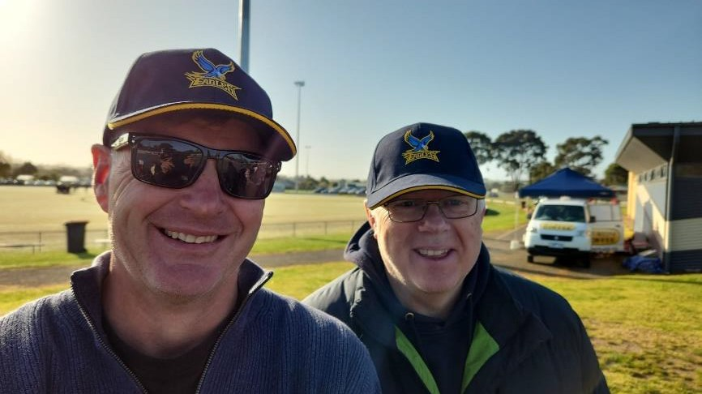
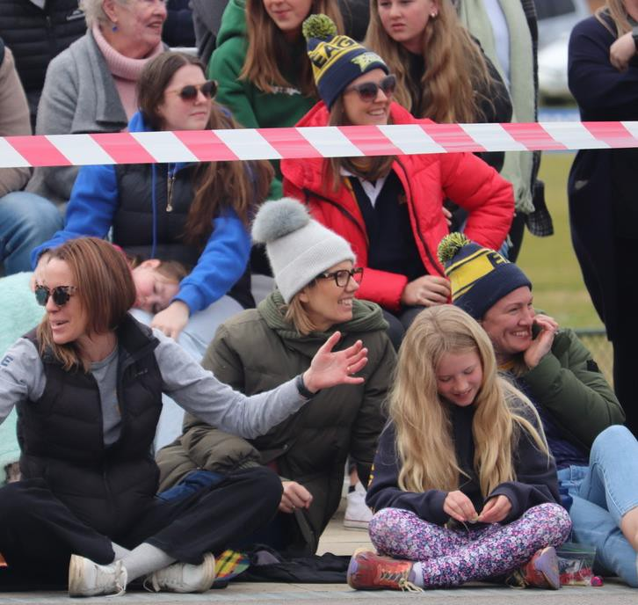
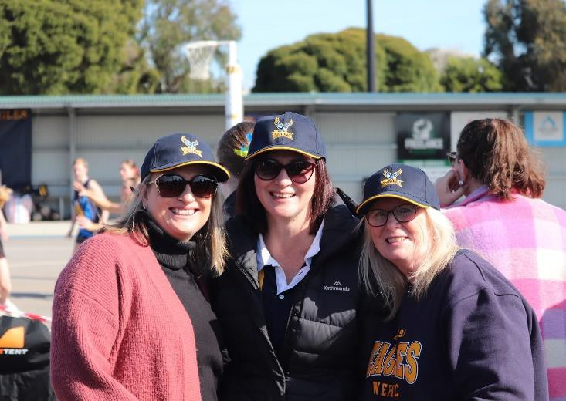
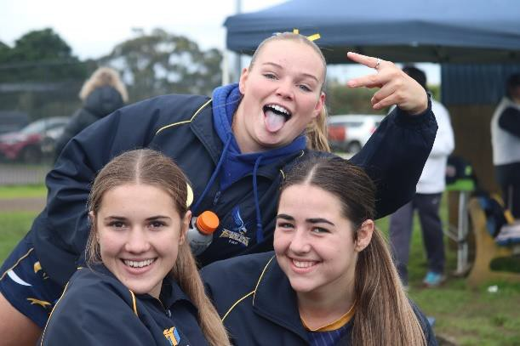
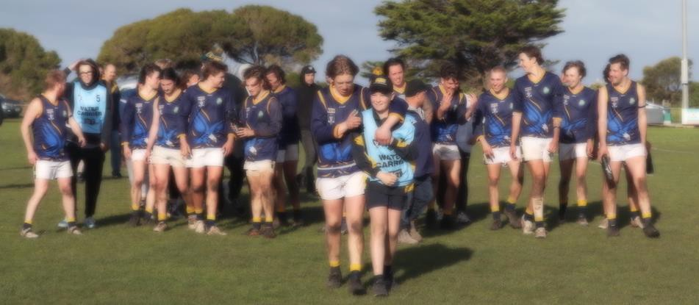
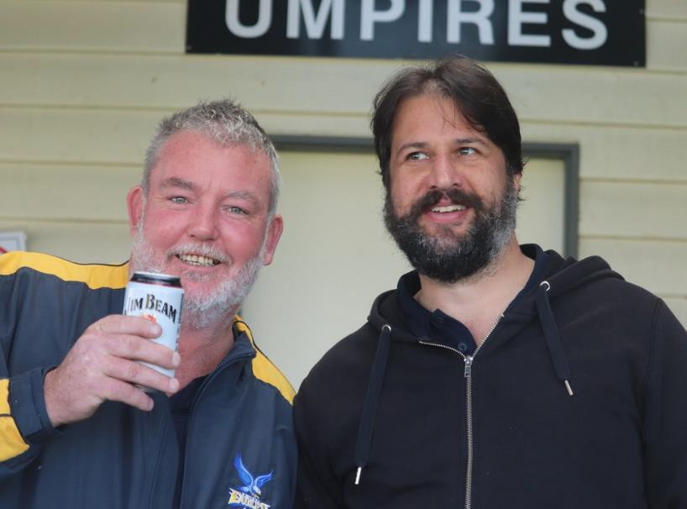
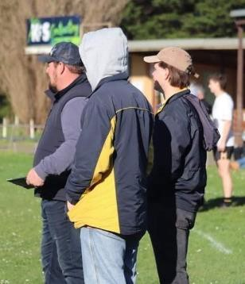
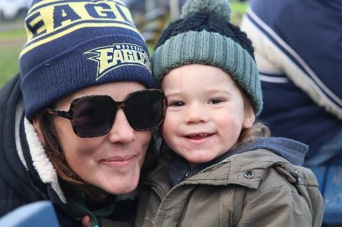
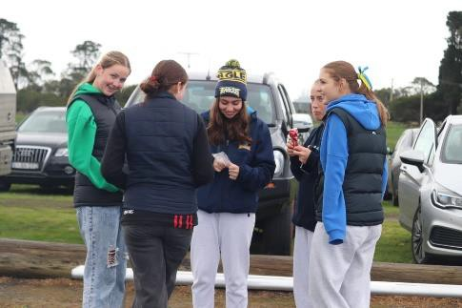
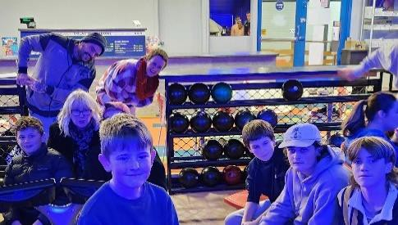
2023, A YEAR WHERE THE GOOD TIMES WERE FLOWING..

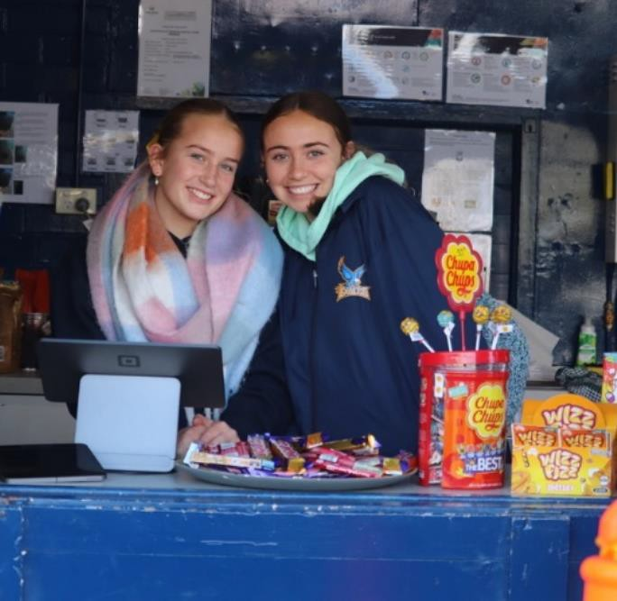
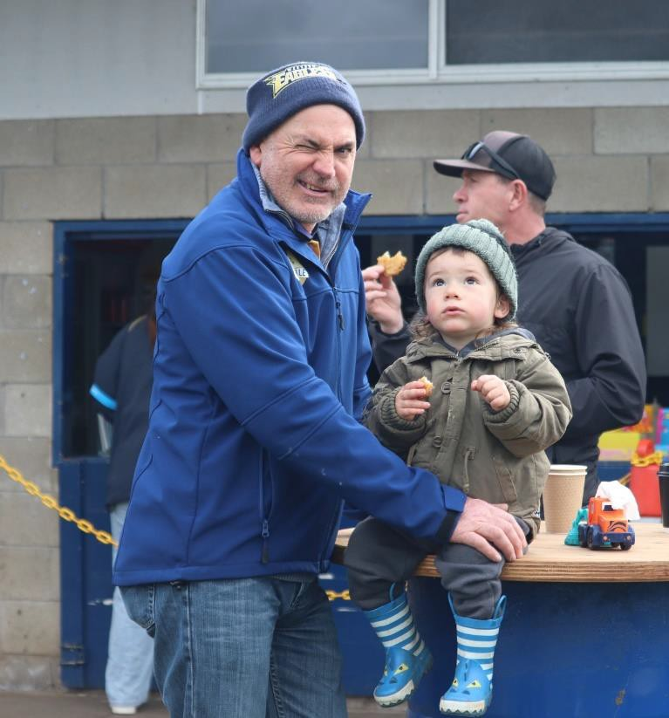
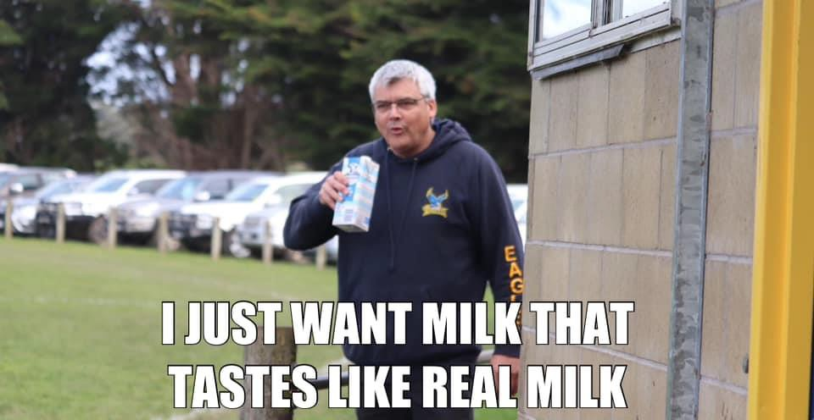
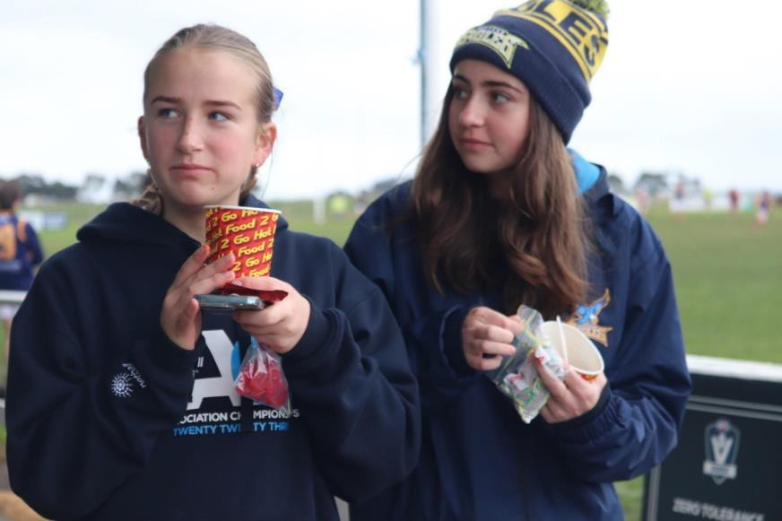
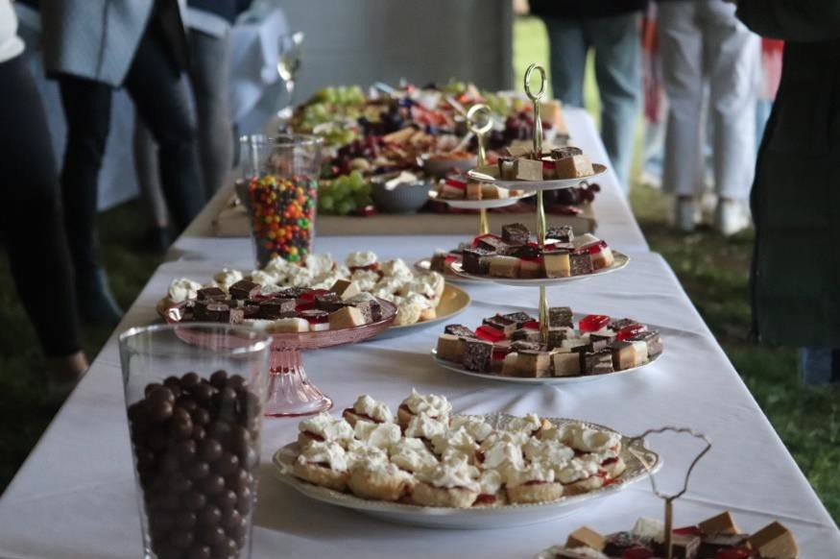
..AND SO WAS THE FOOD (& MILK)..

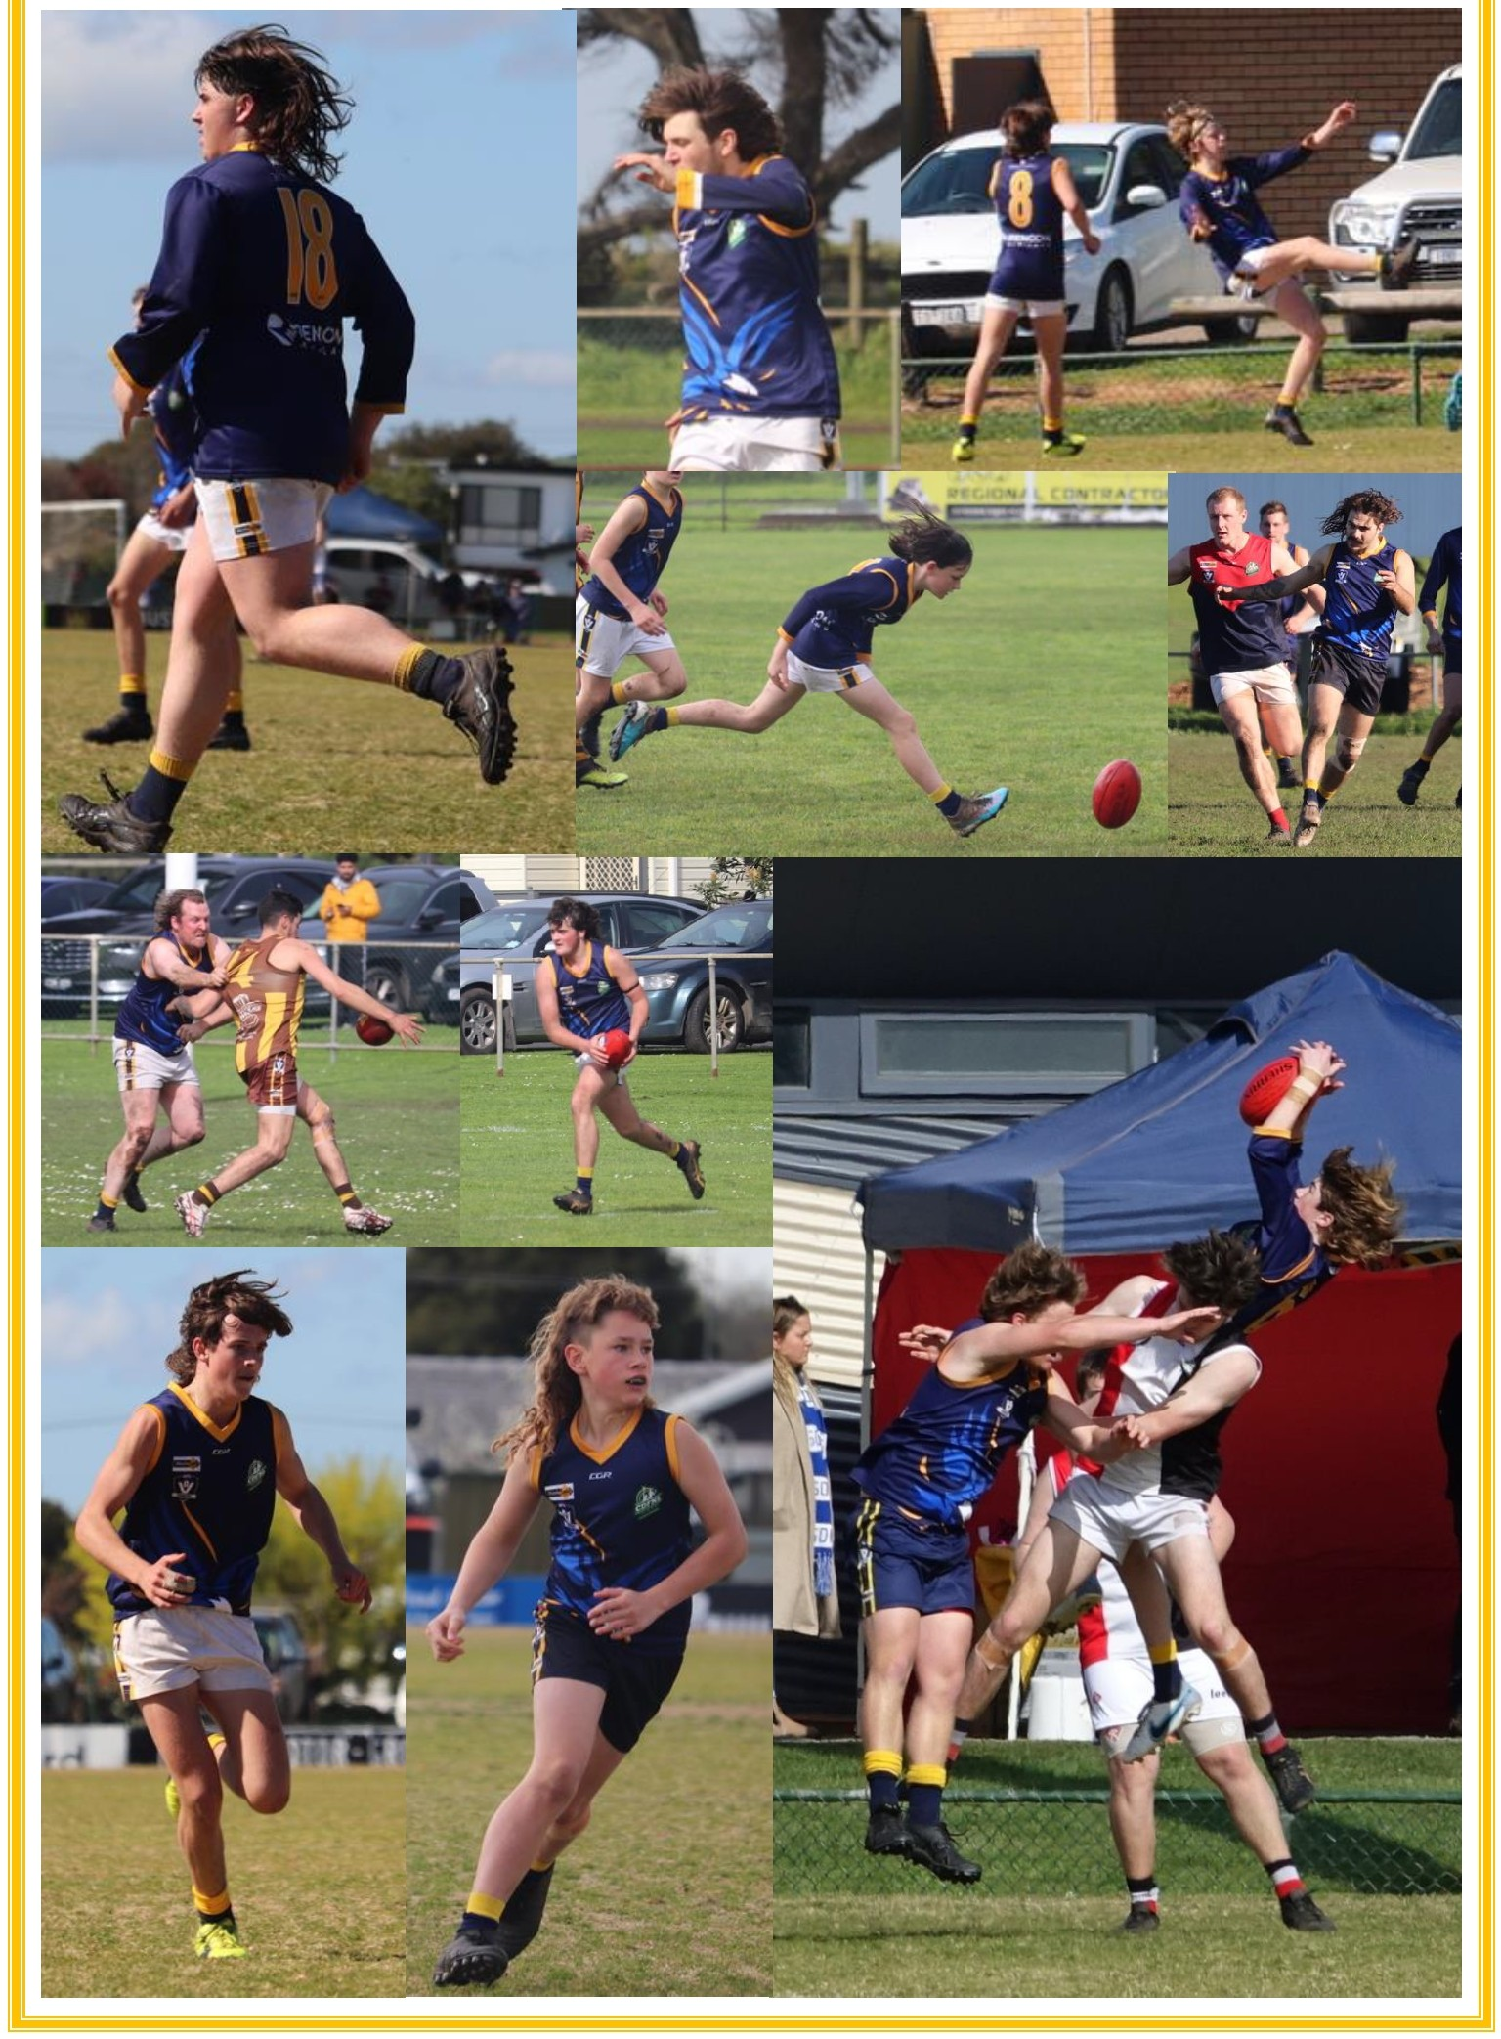
•.AS WELL AS DIE HAIR••

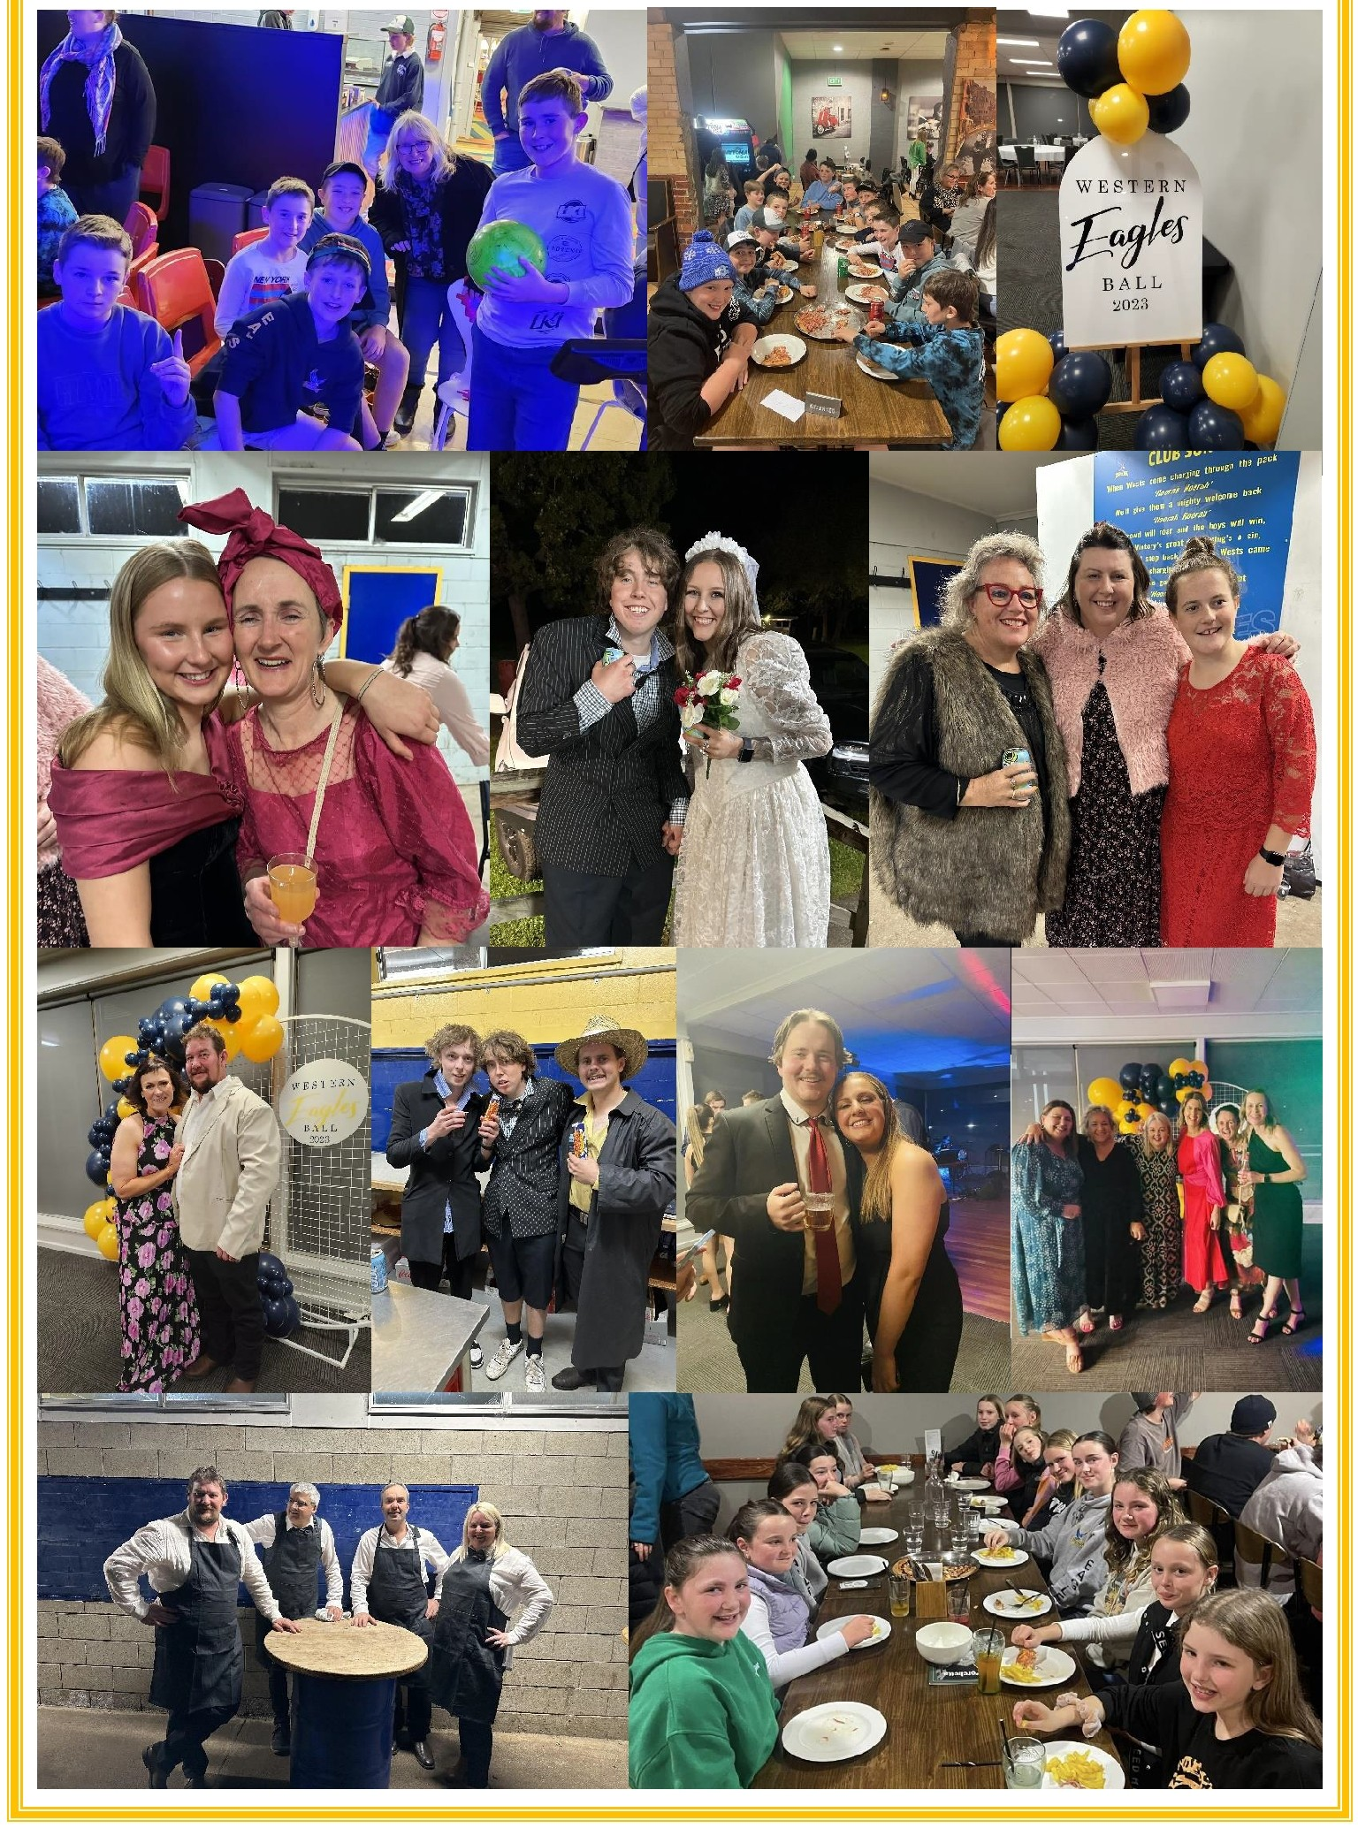
••THANKS FOR THE MEMORIES!

SPONSORS

AG Warehouse | Austral Hotel Aviso Integral Insurance Services Bakers Delight | BDH Constructions Betta Electrical | BKM Fencing
Blooms the Chemist | CCP Civil & Precast Colac
Central Tyre & Auto
Colac Glass and Screens | Colac Tyres
Colac Veterinary Clinic | Colac Windscreens Findex | Garden of Eden | HF Richardson Hip Pocket Workwear | Hulms Bakery
Jims Mowing | Lake Bowling Club Les Riches Electrical Contracting Milville Child Care | Montech Morris Transport
Murnanes Country Fresh Meats Oscar Perrett Carpentry Otway Milk | Otway Optical
PH Plumbing | RB Rural Engineering
Reality Kitchens | Rencon
Rhys Evans | Salon 7 One | SLM Law Spike Colbourne Painter & Decorator Viper Installations | Walsh & Hay Water Supply Specialists |
Westvic Staffing Solutions | YC Feeding

Thank you to all of our sponsors! Your support and contribution to our club is invaluable to us!

